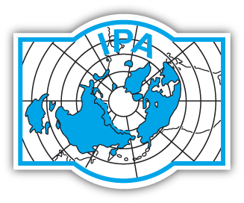
International
Permafrost
Association
IPA Action Group Application

Title of proposed Action Group:
Provide a short and descriptive title for the Action Group.

Action Group Contact:
Name, email, telephone number, title, and institution/affiliation.

Objectives and scope of the Action Group:
Provide here a description of the project in less than 750 words. Keep the background section brief and focus on the definition of clear and targeted objectives. This section will be used to advertise your project to IPA members and the wider public, so please ensure that you address the following points:
a. Why is this activity significant and how does it relate to the objectives of the IPA?
b. Who will undertake the project and what steps will be taken to ensure that its objectives are met?
c. How will it benefit IPA members, the scientific or engineering communities, policy-makers or the general public?

Timeline:
Include here the major milestones of the project as well as the dates envisioned for the delivery of products. Please note that Action Groups can be proposed for a maximum duration of two years. This call is intended for Action Groups operating in 2019 and 2020.

Deliverables:
List here the deliverables of the project (less than 250 words). Try to provide a realistic view of what can be achieved within the time span of the Action Group and include education and outreach deliverables.

Other Action Group Members:
List here the names of the individuals to be involved in the Action Group. Include name, email, telephone number, and institution. Try to provide a size realistically adapted to the size of the project. The individuals making up the Action Group should stem from at least three different IPA member countries. Explain how country balance and involvement of young researchers (PYRN) will be taken into account when allocation of funds is decided.

International dimension:
The IPA is associated with several other international organizations (these can be viewed at https://ipa.arcticportal.org/about-the-ipa/external-relations) and encourages collaborative activities. Please indicate here if there are ties with other organisations and the nature of the collaboration (less than 250 words). If you will collaborate with other IPA Action Groups or Standing Groups, that should also be indicated here.

Budget:
Provide a short description of the budget and the amount requested from the IPA (max. 2500 € per year; maximum of 5000 € over the Action Group duration). Mention other funding sources, even if not confirmed yet. If funding is awarded from the IPA, only the first year’s budget will be confirmed. Awards in subsequent years will be made subject to receipt of an acceptable progress report from the Action Group and in relation to the IPA’s priorities and financial status.

Secretarial support:
Will the action group need secretarial support from the IPA in the form of organisation of conference calls, production of documents, etc. Please described here the level of support requested (less than 250 words).

Please submit a PDF with these fields completed to the IPA Secretariat email at contact@ipa-permafrost.org. Applications must be submitted on or before November 5, 2018.

